**LIBRARY DATABASE**

**USER GUIDE**

The Library database system has mainly two functionalities.

* Reader Function
* Admin Function

**Reader Function:**

All functions related to a reader are in this function. A reader needs to login using his unique ID before he can utilize any benefit provided by the library.

Reader login is as below:

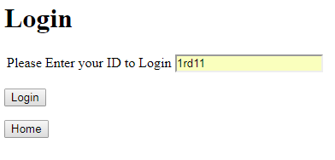

Once the reader has logged in, different functions are displayed to him as below. He can click to select any of the options he wishes.

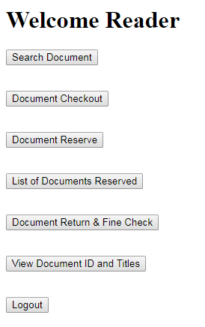

**Search Document:** Search any document in the library database with its name or ID.

**Document Checkout:** Document to be borrowed from the library can be checked out here.Query used to checkout is as below:

INSERT INTO BORROWS (`BORNUMBER`,`READERID`,`DOCID`,`COPYNO`,`LIBID`,`BDTIME`,`RDTIME`)VALUES('$BORNUMBER','$READERID','$DOCID','$COPYNO','$LIBID','$TODAY','$ESTIMATE')

**Document Reserve:** Document can be reserved online here. Below is the query used to reserve document.

SELECT READERID,DOCID,COPYNO,LIBID FROM RESERVES WHERE(RESUMBER = '$RESUMBER' );

**List Of Documents Reserved:** A reader can check all the documents he has reserved.

**Document Return & Fine Check:** A reader can return the book he had borrowed and check to pay fine, if any.

**List of Documents:** Displays all the documents of the library database with ids ID and titles.

**Admin Function:**

All functions related to an admin are in this function. Library personnel should have a valid user id and password to login. Only after authenticating credentials, the admin activity can be performed.

We have also provided an option to create a login for new library personnel.

Admin login is as below:

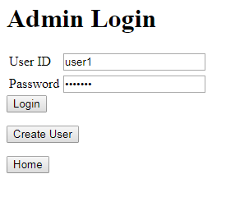

Once the library personnel has logged in, different functions are displayed to him as below. He can click to select any of the options he wishes.

**Add A Document:** Admin can add a new document into the database.

**Find a Document & Status:** By entering the name or id of a document, admin can find out its status.

**Add a New Reader:** Admin has privileges and can add new reader into the library system here. Below query is used to add data.

INSERT INTO READER (`READERID`,`RTYPE`,`RNAME`,`ADDRESS`) VALUES ('$READERID','$RTYPE','$RNAME','$ADDR');

**Branch Information:** Lists out the information of all the branches of the library.

**Top 10 borrowers and Number of books borrowed:** Admin can find out who are the top 10 borrowers of a particular branch and the count of books they have borrowed here. Below query is used to retrieve data.

SELECT B.READERID AS READERID, R.RNAME AS RNAME, COUNT(*) AS COUNT FROM READER R, BORROWS B WHERE B.READERID = R.READERID AND B.LIBID='$LIBID' GROUP BY B.READERID ORDER BY COUNT DESC LIMIT 10;

**Top 10 frequently borrowed books in a branch:** Admin can find out which are the top 10 books that are frequently borrowed in a particular branch here. Below query is used to retrieve data.

SELECT B.DOCID AS DOCID, D.TITLE AS TITLE, COUNT(*) AS COUNT FROM BORROWS B, DOCUMENT D WHERE B.DOCID=D.DOCID AND LIBID = '$LIBID' GROUP BY DOCID ORDER BY COUNT DESC LIMIT 10;

**10 Popular books of the year:** Admin can check the popular books of the year here. Below query is used to retrieve data.

SELECT B.DOCID AS DOCUMENT_ID,TITLE, COUNT(*) AS COUNT FROM BORROWS B, DOCUMENT D WHERE B.DOCID=D.DOCID AND B.DOCID IN (SELECT DOCID FROM BOOK) GROUP BY B.DOCID ORDER BY COUNT DESC LIMIT 10;

**Average fine per reader:** Admin can find out what is the average fine per reader here.

